IoD Scotland Director of the Year Awards 2025
Categories and criteria

Message from the IoD
One of the few cross-sector Awards programmes, the IoD Scotland Directro of the Year Awards celebrates leadership talent, success and achievement.
Ongoing tough economic operating circumstances and geopolitical turbulence, not to mention the emergence of A have seen the continuance of exceptionally tough operating conditions, forcing directors to reassess business models and respond at speed with bold, innovative decisions. These monumental efforts deserve recognition. Whatever your sector or organisation – whether you are a director in an established company, innovative start-up, family business, SME, NED or Third Sector – we want to hear from you.
We hope you will consider submitting an entry – remember, you can enter more than one category and entry is free.
Top tips for completing your entry
Remember that the IoD is about individuals, not organisations, so your answers should be biased to what you have done, achieved or influenced. If the organisation has made great achievements, stress what you did to make it happen.
- Vision: articulate your vision and how you are driving it forward
- Approach to challenge and innovation: talk about the challenges you have encountered and how you overcame them. What did you learn from the experience? Tell the judges how you have innovated with new ideas, approaches and processes.
- Company culture: how do you foster a good culture? What is your attitude to Continual Professional Development and Corporate Social Responsibility for you and your staff? How do you drive this through the organisation?
- Corporate governance: if your organisation is too small to have a full board, demonstrate how you ensure you make good decisions, for example a mentor or consultant. If you are a larger organisation, discuss the role of the independent chair and NXDs and how you ensure the board is balanced and remains up to date.
- Leadership: describe why your team would see you as a role model and how you have provided strong leadership at times of stress and challenge and how you support staff and communicate with clients, stakeholders.
What is a director?
Directors are responsible for leading their organisation, defining its strategic direction and, along with the rest of the board, they have a duty to make informed decisions and exercise reasonable care, skill and diligence on behalf of that organisation. They owe a duty of trust, loyalty and confidentiality to their organisation and they must act in good faith in the best way to promote its long-term success. At the IoD, we recognise that practising, aspiring (including student) and retired directors, all have a crucial role to play in the director community.
The IoD believes that all directors, regardless of their specific role on the board, the sector or industry in which they operate, or the size of the organisation, need to demonstrate competence in a wide range of areas in order to be truly effective leaders.
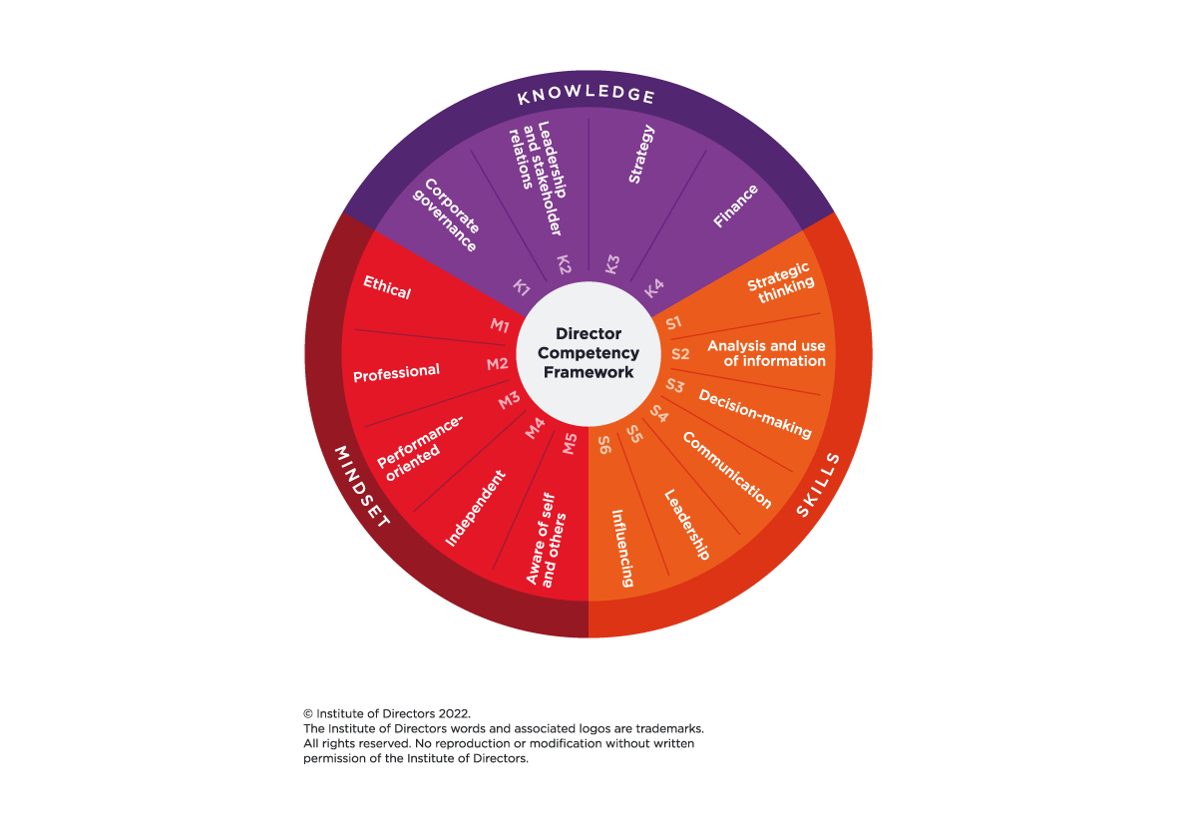
The IoD’s Director Competency Framework sets out these competencies, divided up into knowledge, skills and mindset. Besides the concrete skills and explicit knowledge required to carry out their duties, directors should also bring an ethical mindset, integrity and independence. When it comes to an organisation’s ethical standards the directors and senior management need to be beyond reproach and ‘set the tone at the top’. View the full framework

Please note
- You may edit your entry after submitting, up until the entry deadline.
- Please make sure all your personal details are entered accurately, including contact details, as this will be used in the awards presentation if selected as a finalist.
- You may find it easier to prepare answers in a Word document then copy and paste them into the form fields.
- You are eligible to enter more than one category, as long as the work submitted meets the criteria.
- You can use the ‘copy’ feature to create a copy of your entry and change the category as required.
- If you are submitting an application on behalf of someone else please complete the application in first person and list contact details of the main point of contact regarding the application, throughout the process.
Section one: General Criteria Questions
Part 1 – Vision, Purpose, Values & Ethics

1. What was your role in developing and embedding your organisation’s vision, purpose, and values? (60-100 words)
2. How have you personally championed the values of the organisation? (60-100 words)
Part 2 – Strategic thinking and stakeholder management

1. How have you contributed to the Board’s strategic decision-making process, particularly in relation to the financial consequences and what were the broader risks? (60-100 words)
2. In developing or reviewing strategy, how have you accommodated the interests of your various stakeholders? (60-100 words)
Part 3 – Managing the business

1. What role have you played in developing and evaluating business operating plans?
(60-100 words)
2. What role have you played in ensuring the thorough review of operational performance? (60-100 words)

Part 4 – Applying good governance/risk management

1. What has your role been in ensuring the Board is compliant with legal and regulatory requirements? (60-100 words)
2. In your Board role, what are your regular methods of communication with stakeholders - including staff - to monitor and review feedback? (60-100 words)

Section two: Category-Specific Question
sector
- Director of the Year – Public Sector
Leadership is critical to good public governance, including good planning, efficiency, transparency and accountability. This award is open to leaders of public services, including public agencies, national bodies and governmental departments.
The judges are looking for leaders that can demonstrate how to get the best out of others' professional expertise and their contribution to civic society.
Wider considerations include how leaders have explained their societal contribution and impact to their stakeholders in the context of the environment in which they operate, their viability and good corporate governance.
Q. Describe the processes or programmes that you have put in place to engage with your stakeholders to ensure your strategy or vision is successful. This should include how you support and motivate employees and establish a positive working atmosphere. How have you ensured that the company fulfils its charitable/public service objectives. (500 words maximum)

- Director of the Year – Third Sector
Leadership in the voluntary sector is critical to good governance, including planning, efficiency, transparency and accountability. This award is open to directors whose organisations are charities, community organisations or social enterprises that do not generate profit for individuals.
The judges are looking for leaders that can demonstrate how to get the best out of others for the benefit of their organisation and the people/communities it serves. You will have a compelling vision and demonstrate a commitment to empowering others, inclusive decision-making, collaborative leadership, and innovative solutions to fulfil your organisational purpose and values.
The judges will also consider how you demonstrate impact in the context of your operating environment, financial sustainability and good governance.
Q. Describe the processes or programmes that you have put in place to engage with your stakeholders to ensure your strategy or vision is successful. This should include how you support and motivate employees and establish a positive working atmosphere. How have you ensured that the company fulfils its charitable/public service objectives? (500 words maximum)

SIZE
- Director of the Year – Start Up
This award recognises upcoming leaders who have demonstrated excellent entrepreneurial potential, ability, ambition, creativity and vision in new or established businesses who have operated at director level for less than three years.
We are looking for someone with an entrepreneurial approach who is a calculated risk taker and innovator who is already generating excitement in the marketplace and who also recognises the importance of good corporate governance/ company culture.
**Start Up is defined as trading for less than 36 months**
Based on the UK and Scottish Government business size definitions below:
https://www.gov.uk/government/publications/fcdo-small-to-medium-sized-enterprise-sme-action-plan/small-to-medium-sized-enterprise-sme-action-plan
https://www.gov.scot/publications/businesses-in-scotland-2023/pages/business-size/

Q. Tell us in 500 words about your entrepreneurial, corporate governance journey and why you should be our Director of the Year? Your answer should consider themes around leadership, culture and performance. (500 words maximum)

- Director of the Year – Small Business (Up to £10 Million)
This award is designed to celebrate those directors working in a business that employs under 50 employees and has an annual turnover of less than £10 million.
This award will go to the business that can show outstanding initiative, boldness and imagination in enterprise, sustainability, as well as sound management practice, good corporate governance and commercial success.
Q. Please demonstrate how you have successfully overcome challenges to drive forward your business plan and exceed business objectives. Provide examples of sound business and financial planning, staff support, motivation to meet business objectives and a clear plan for future growth of the organisation.
You should reference your contribution to board composition, including identifying any gaps in board competency, and how you have fostered meaningful engagement with your stakeholders. (500 words maximum)

- Director of the Year – Medium / Large Business (£10 Million +)
This award is designed to celebrate those directors working in a medium or large business that has an annual turnover of more than £10 million and/or 50+ employees
Judges will look at how financial targets and KPIs have been met/exceeded, innovation, the vision for growth, sustainability, evidence of good corporate governance and the leader’s understanding of key challenges, customers and the changing business landscape.
Q. Please demonstrate how you have successfully overcome challenges to drive forward your business plan and exceed business objectives. Provide examples of sound business and financial planning, staff support, motivation to meet business objectives and a clear plan for future growth of the organisation.
You should reference your contribution to board composition, including identifying any gaps in board competency, and how you have fostered meaningful engagement with your stakeholders. (500 words maximum)
specialism
- Director of the Year – Operations
- Director of the Year – Finance
- Director of the Yar – People & HR
- Director of the Year – Sustainability and Innovation
- Director of the Year – Sales & Marketing
- Director of the Year – Specialist*

These award categoreis recognize leaders who have excelled in specific decision making positions and roles.
Judges are looking for examples of creativity and innovation, directly lined to the role, coupled with evidence of leadership with particular emphasis around contribution to workplace culture and environment.
Key success factors will include inclousive decision making, collaborative leadership and implementation of strategy and delivery agsinat KPIs.
The judges will also consider how you demonstrate impact in the context of your operating environment, financial sustainability and good governance.
Q: How have your leadership capabilities and [specialism] expertise driven organisational success? Provide specific examples of how you navigated challenges, managed risks, influenced strategic decisions, engaged with other company directors, and delivered measurable outcomes that showcase your impact as a [specialism] director. (500 words maximum)
- Director of the Year – Non Executive Director
NEDs can bring exceptional value to any organisation; their role is to provide a creative contribution to the board by providing independent oversight and consteuctuve challenge to the exexutive directors on a broad range of subjects.
The most important qualities are judgement, wisdom and the ability to gain respect and attention from the colleagues.
This award recognizes individuals that have made a significant contribution to the organisation’s strategy, impacted on the financial success of the company, demonstrated high ethical standards and promote the practive of good corporate governance.
Q. Please provide examples of how you have efficiently identified and managed risk (operational, financial or reputational) stay up to date with company’s performance and management and how you have positively engaged and contributed to the board.
You should look to demonstrate how your ethical leadership has contributed to the success of the organisation(s) you serve. (500 words maximum)

Please also include a testimonial (as an attachment) from a Board member of any Board that you are appointed to at the time of your entry.

- Director of the Year - Emerging
This award recognises upcoming leaders who have demonstrated excellent entrepreneurial potential, ability, ambition, creativity and vision in new or established businesses who have operated at director level for less than three years.
We are looking for someone with an entrepreneurial approach who is a calculated risk taker and innovator who is already generating excitement in the marketplace and who also recognises the importance of good corporate governance/ company culture.
Q. Tell us in 500 words about your entrepreneurial, corporate governance journey and why you should be our Director of the Year? Your answer should consider themes around leadership, culture and performance. (500 words maximum)

- Director of the Year – Chair’s Award
Awarded at the discretion of the IoD Scotland national chair.

